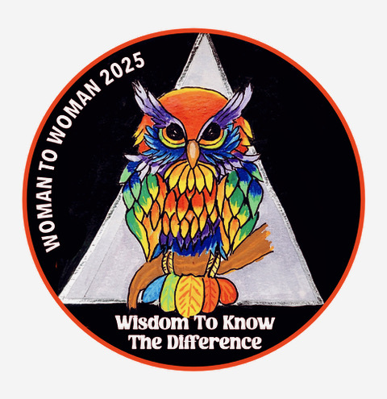
43rd Annual Woman to Woman Conference
April 11, 12, 13th 2025
Wyndham Hotel
5321 Date Ave., Sacramento, CA 95841
916-338-5800
Room Rates $139.00 plus tax
Cut off date is March 25th 2025

MAIN SPEAKERS
Friday | 8 pm | Deborah C. | Laguna Beach CA
Saturday Al-Anon | 10 am | Andrea C. | Amarillo, TX
Saturday | 1 pm | Jeanette M. | Sacramento, CA
Saturday | 8 pm | Kristina W. | Fairfax, CA
Sunday | 10 am | Allison C. | Goleta, CA
Registration: Valerie C. 916-847-4673 Conference Chair: Cyndi G. 916-968-3212
Raffle Donations: Chair: Christina S. 916-600-8696
Send COMPLETED registration form and a check payable to:
NCWW – PO BOX 2008, Fair Oaks, CA 95628 NO. LATER THAN March 21, 2025
IMPORTANT: Pre-order T-shirts are available on the website or below and must be ordered by March 21, 2025
NAME:_________________________________ADDRESS:___________________________________________
PHONE:___________________________EMAIL:_______________________________________________
Non Refundable $35.00 Pre-Registration_ __________I would like to donate $_________for the
Scholarship Fund
Pre-Order T Shirts:______S______M_____L_____XL______XXL_______XXXL@$15.00 each
TOTAL T-Shirt______________
Saturday Banquet 82.00: A Taste of California: Salad, Tri Tip. Salmon, Vegetables, Mushroom Ravioli, Chocolate Cake
TOTAL INCLUDING BANQUET AND T-SHIRTS $_______________________
ALL BANQUET AND PRE-REGISTRATION MUST BE RECEIVED BY MARCH 21, 2025
Regrettably, NO CHILDREN ARE ALLOWED AT THIS EVENT
$40.00 Registration at the door
If you would like to volunteer this year, please contact Volunteer Chair: Suzy L. 916-709-4925
_If you would like to be of Service at next year’sConference, ______
I’m attending as a Member of AA________I’m attending as a Member of Al-Anon__________

If you are in need of a scholarship, please submit a request in wring, in advance. Scholarship covers registration only and requires a 2
hour service commitment Limited times will be availablee.

